1. Open Eclipse

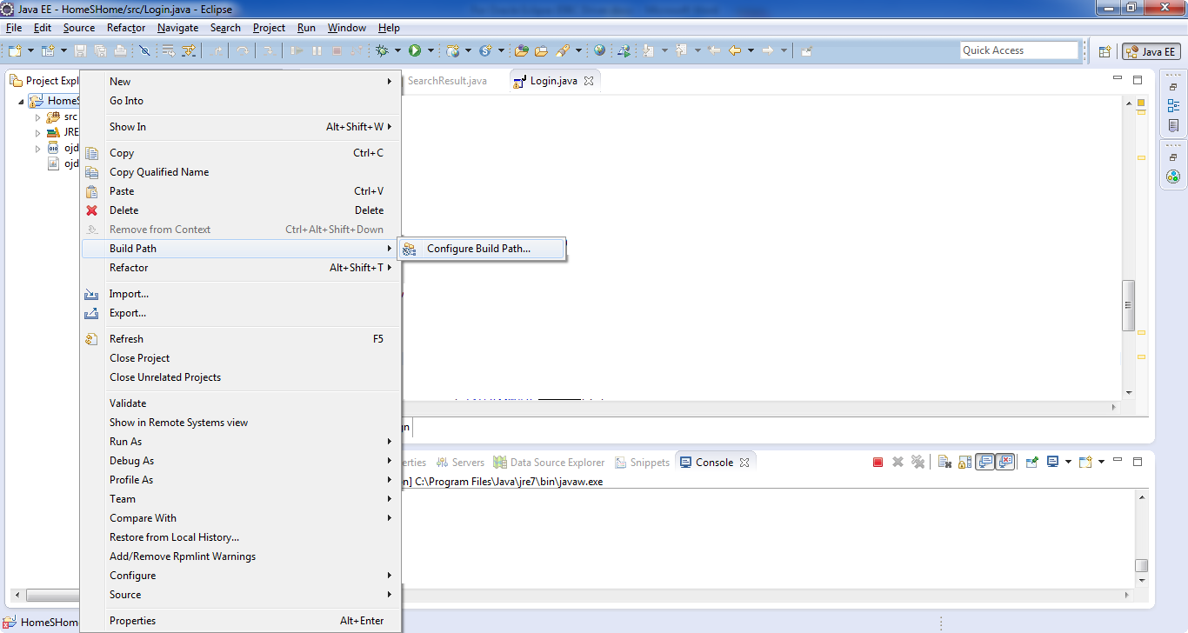

1. Right click the project>Build Path>Configure Build Path(Click it)

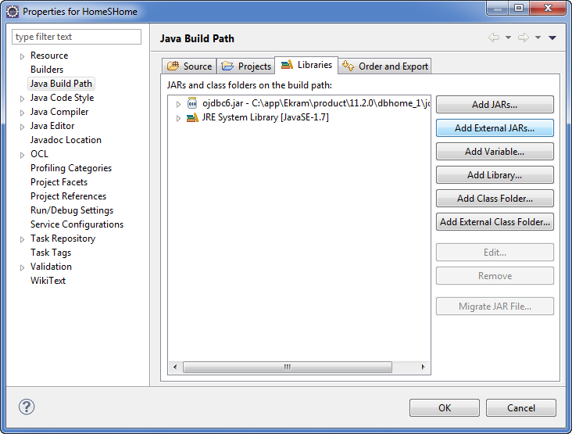

1. Under Java Build Path>Libraried>Add External JARs
2. Find the ojdbc6.jar from Oracle apps
3. For me it was in: C:\app\Ekram\product\11.2.0\dbhome_1\jdbc\lib\ ojdbc6.jar
   1. For me it was Ekram, for your PC it will be different.
4. Open And OK

That’s it.